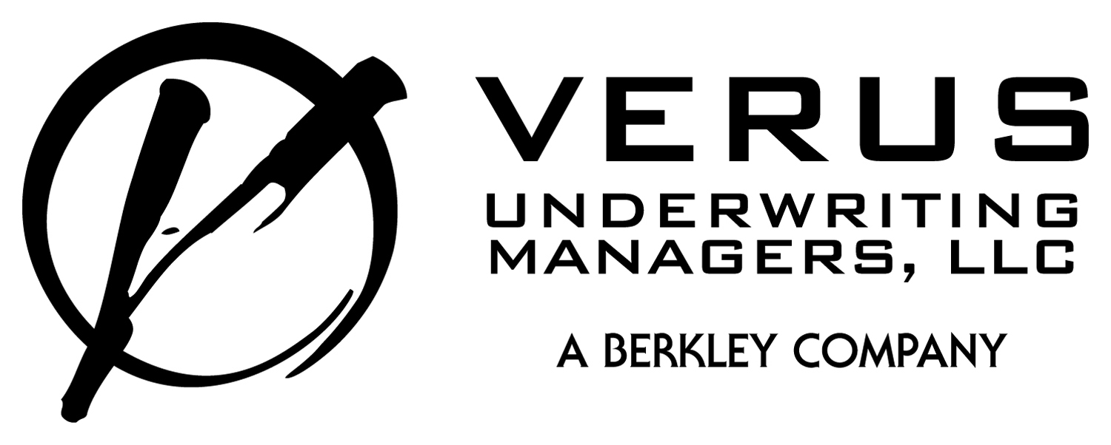
GARAGE – AUTO & TRUCK DISMANTLERS SUPPLEMENTAL APPLICATION

Applicant Name:
- What percentage of your work is?
Auto & Truck Dismantling %
Service & Repair %
Used Car Sales (as is) %
Used Car Sales (body rebuilt) %
Other: %

- Are Customers allowed in the yard to pull their own parts?
Yes No

- What are your stacking procedures?
None, we don’t stack
3 vehicles high or less

- What are your crushing procedures?
None, we don’t have a crusher
We have a crusher and prohibit customer access to the yard
We have a portable crusher and crush autos for other dismantlers
We hire a service who brings a portable crusher to our yard

- What are your hauling procedures?
None, we don’t haul
We do haul and stacks of hulls are chained to the truck bed or wrapped with netting
The distance traveled from our yard to the scrap dealer is less than 100 miles

MISREPRESENTATION, CONCEALMENT AND FRAUD
*ANY PERSON WHO KNOWINGLY AND WITH INTENT TO DEFRAUD ANY INSURANCE COMPANY OR OTHER PERSON FILES AN APPLICATION FOR INSURANCE OR STATEMENT OF CLAIM CONTAINING ANY MATERIALLY FALSE INFORMATION, OR CONCEALS FOR THE PURPOSE OF MISLEADING, INFORMATION CONCERNING ANY MATERIAL FACT THERETO, MAY BE COMMITTING A FRAUDULENT INSURANCE ACT, AND MAY BE SUBJECT TO A CIVIL PENALTY OR FINE. *NOT APPLICABLE IN ALL STATES.

Signature of Applicant _________________________________ Date / /

