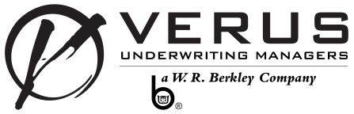
EMERGENCY VEHICLE & EQUIPMENT
SUPPLEMENTAL

OPERATIONS

- What percent of work is performed at:
% Your Shop?
% Customer Locations?

- What percent of the operation is:
% General Service?
% Emergency Vehicle Specific?

General: Emergency Vehicle Specific:
% Brakes % Aerial Ladder Service
% Electrical % Custom Vehicle Conversions
% Engine Repair % Fabrication
% Hydraulics – general % Ground Ladder Service
% Maintenance % Hydraulics – Lifting Apparatus
% Oil & Lube % Ladder & Hoses
% Radiator % Lights, Sirens, Radios
% Suspension/Frame Repairs % Pump Service
% Tires % Pump Testing
% Tune Up % Tank Clean/Repair - Internal
% Wash/Detail % Tank Repair - External
% Other % Other

- If any Emergency Vehicle Specific work is done, please provide details on the following:
- Qualifications:
- Experience:
- Work Performed:

- Do you install, sell or service medical equipment for ambulances or paramedic vehicles? Yes No

- Do you test drive extra-heavy vehicles off-premises on public roadways? Yes No
If yes, do drivers possess CDL licenses? Yes No

- What parts, equipment, and accessories do you fabricate and how are they used?

APPLICANT’S SIGNATURE
PRIVACY NOTICE
Personal information about you may be collected from persons other than you in connection with this application for insurance. Such information as well as other personal and privileged information collected by us or our agents may in certain circumstances be disclosed to third parties without your authorization. You have the right to review your personal information in our files and can request correction of any inaccuracies. A more detailed description of your rights and our practices regarding such information is available upon request. Contact your agent or broker for instructions on how to submit a request to us.
MISREPRESENTATION, CONCEALMENT AND FRAUD
*Any person who knowingly and with intent to defraud any insurance company or other person files an application for insurance or statement of claim containing any materially false information, or conceals for the purpose of misleading, information concerning any material fact thereto, may be committing a fraudulent insurance act, and may be subject to a civil penalty or fine. *not applicable in all states.
Signature of Applicant Date
Agency Name
Signature of Agent Date

